caB2B Milestone 3 design document

Table Of Contents
Querying caArray using caB2B 2
Scope 2
Prerequisite 2
Supporting caArray in caB2B 2
Overview 2
Why customize IRecord for caArray? 2
Steps in customizing IRecord for caArray 2
IRecord and its extensions for caArray 2
Query Result Transformers 3
Inbuilt implementations of IQueryResultTransformer 4
Customization for caArray 5
Result Configuration XML 6
Path Curation Design 7
Class Structure 7
Interface diagram 7
Class Diagram 7
Database schema 8
User interface 9

Querying caArray using caB2B

Scope
Querying the caArray data service requires extensions to the default caB2B querying mechanism. This document first explains the reason why these extensions are required. It then explains the design of the relevant portions of caB2B query module, and the actual extensions implemented to support querying caArray.
Note that the content of this document is an edited extract of Chapter 13 “Record Customization” of the caB2B 1.0 design document.

Prerequisite
Any application that is to be supported by caB2B has to be registered with the metadata repository of caB2B. So, the caArray domain model xml has to be loaded to the caB2B metadata repository.

Supporting caArray in caB2B

Overview
In caB2B, the user defines a query on the DAG. This user-defined query is transformed to appropriate DCQL. The DCQLQueryResults obtained by executing this DCQL is then transformed into an IQueryResult.

The IQueryResult is a caB2B-specific representation of the results. Logically, IQueryResult is a collection of records (represented by IRecord’s). This chapter explains how this caB2B-specific representation (i.e. IRecord) is customized to support querying the caArray data service.
The IRecord IRecord is a map from an attribute to its value.

Why customize IRecord for caArray?
The default IRecord represents the record of a UML class, as obtained from a data service that uses the default (de)serialization mechanisms of caGrid. A custom subtype of IRecord would be defined to add more information to such a record.
The caArray data service provides custom (de)serialization. It returns more information than can be represented by IRecord; it returns identifiers of classes associated to the target class. To store this information, a custom record has to be defined.

Steps in customizing IRecord for caArray
- Define appropriate subtype of IRecord; this is ICaArrayRecord.
- Implement a query result transformer. This will be responsible for transforming CQLResults into ICaArrayRecord.
- Register the custom implementation in the configuration xml “ResultConfiguration.xml”.
The following sections explain the above steps in detail.

IRecord and its extensions for caArray
Following are the basic interfaces; the other interfaces are either markers or mixins to represent the records from caArray data service.
- IRecord: The most basic interface; it represents a record as a set of attribute-value pairs.
- IRecordWithAssociatedIdentifiers: Represents a record that can provide identifiers of associated classes as well.
- ICategorialClassRecord: Represents the records of a category. The records form a tree; the structure of the tree corresponds to the tree of classes in the category.

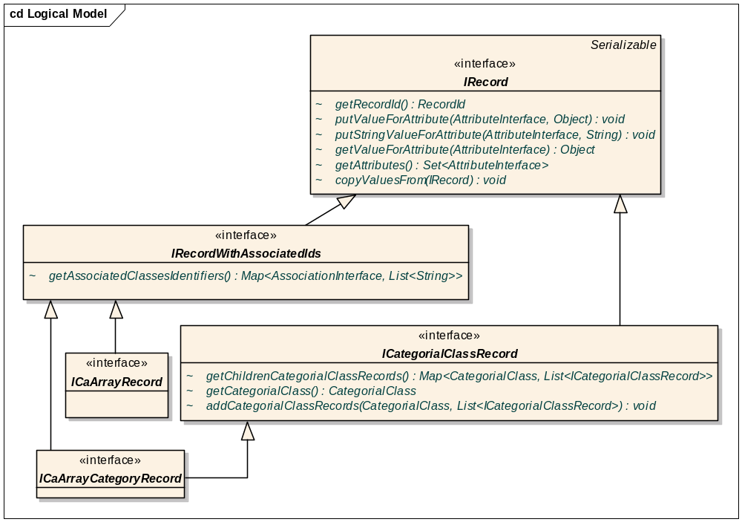
IRecord and its caArray extensions

Query Result Transformers
A query result transformer is defined by the interface edu.wustl.cab2b.server.queryengine.resulttransformers.IQueryResultTransfomer<R extends IRecord, C extends ICategorialClassRecord> and is responsible for executing a DCQL and transforming the results into an appropriate IQueryResult. Following are the methods in IQueryResultTransformer:
- IQueryResult<R> getResults(DCQLQuery query, EntityInterface targetEntity);
<R> the type of records created when executing a query for a class.
  - query the DCQL.
  - targetEntity the target entity (corresponds to the target object of the dcql).
- IQueryResult<C> getCategoryResults(DCQLQuery query, CategorialClass categorialClass);
<C> the type of records created when executing a query for a category.
  - query the DCQL whose target object corresponds to the actual UML class represented by the categorial class.
  - categorialClass the categorial class.

Class diagrams for query result transformers are shown below.
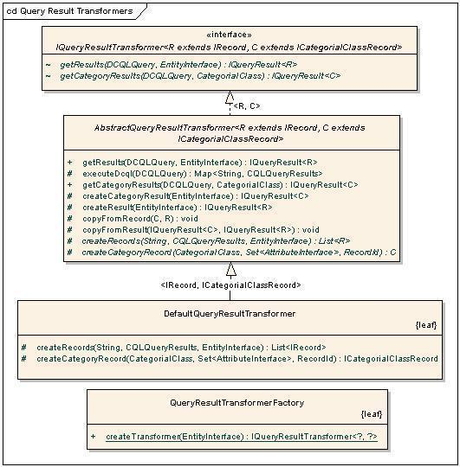
Query Result Transformers

Note: The text on the generalization links refers to type parameters e.g. declaration of DefaultQueryResultTransformer is class DefaultQueryResultTransformer extends AbstractQueryResultTransformer<IRecord, ICategorialClassRecord>
QueryResultTransformerFactory refers ResultConfiguration.xml to obtain the appropriate transformer.

Inbuilt implementations of IQueryResultTransformer
- AbstractQueryResultTransformer This abstract class provides a skeletal implementation of a query result transformer. Concrete implementations need only implement the createRecords() and createCategoryRecords() methods. Additional hooks are provided and can be used to customize the creation and population of the records in the result.
- DefaultQueryResultTransformer This is the caB2B default query result transformer. It parses the gov.nih.nci.cagrid.cqlresultset.CQLQueryResults xml and extracts the values for the attributes of the target entity. The records in the results are of the basic types IRecord and ICategorialClassRecord.

Customization for caArray
The interface cab2b.server.caarray.resulttransformer.ICaArrayRecord is used to represent a record of the caArray application. As explained previously, the caArray service returns identifiers of classes associated to the target class. Thus, an application-level transformer is defined for caArray that uses the caArray deserializers and reads this information.
- AbstractCaArrayResultTransfomer: Provides an implementation of the method createRecords() of AbstractQueryResultTransformer. It also handles the deserialization of the caArray results xml into objects and transforms these objects to ICaArrayRecord using reflection.
- DefaultCaArrayResultTransformer: This is the transformer for classes in the caArray application. It provides an implementation of the createCaArrayRecord() method of AbstractCaArrayResultTransfomer.

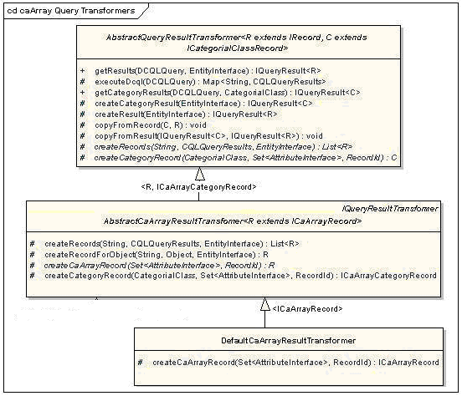
caArray Query Result transformer

Result Configuration XML
The query result transformer defined for caArray has to be registered with the caB2B application in the ResultConfiguration.xml file as shown below. Refer the first entry <application name=”caArray” >.
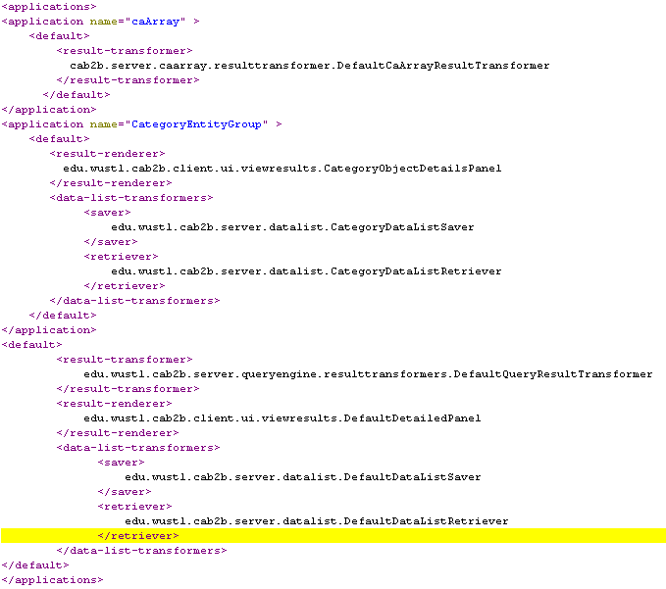

Path Curation Design

Class Structure
Refer to the requirement document to understand the expected functionality of path curation
IAssociation represents a direct linkage between two classes. There are two extensions of IAssociation. IIntraModelAssociation represent the link between two classes from the same model. IInterModelAssociation represent the link between two classes from different models.

An IPath represents a navigable way between a source and a destination class. It is composted list of IAssociation. It will have at least one

ICuratedPath is defined for set of entities (classes), it is composed of one or many IPath which form a non-cyclic graph between given set of entities.

The implementing classes of these interfaces are hibernate objects. Save-Update-delete operations will be performed using DAO pattern. The interface structure will be like following

Interface diagram
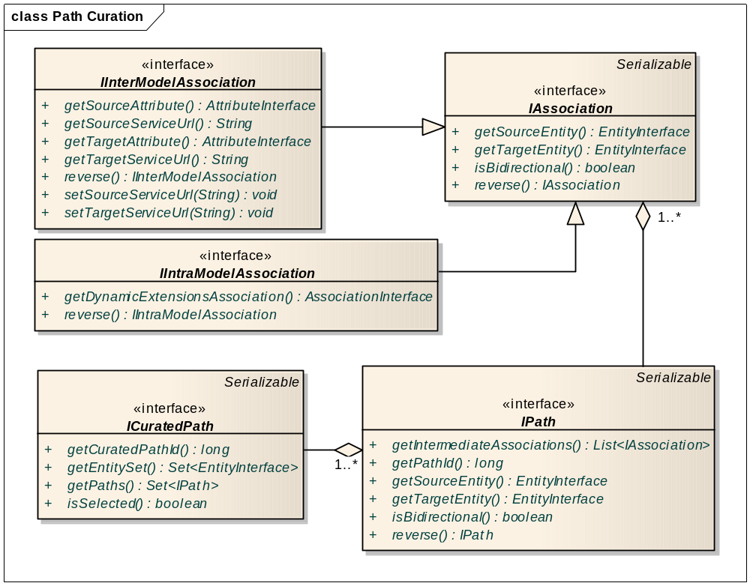
Figure 1 Path Curation Interfaces

Class Diagram
The classes involved in the path curation will be as follows
ModelAssociation implements IAssociation
InterModelAssociation implements IInterModelAssociation extends ModelAssociation
IntraModelAssociation implements IIntraModelAssociation extends ModelAssociation
Path implements IPath
CuratedPath implements ICuratedPath

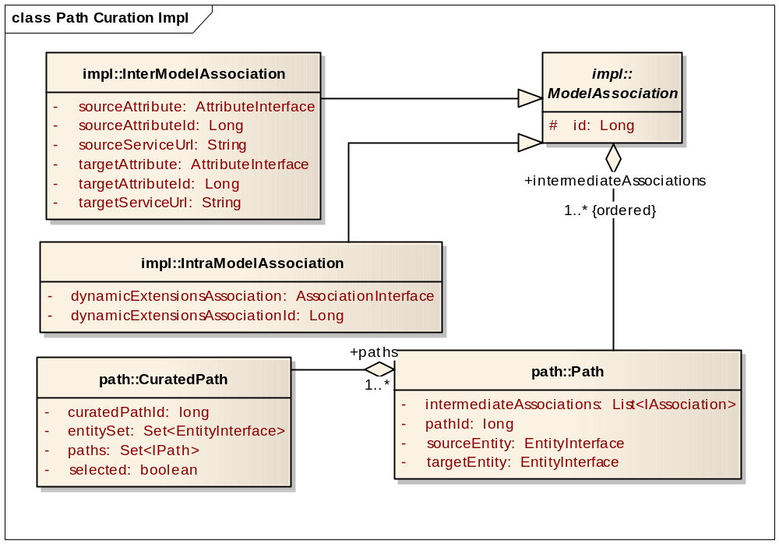
Figure 2 Path Curation Java beans

Database schema
The DDL of the tables will be

/*INTERMEDIATE_PATH contains ASSOCIATION(ASSOCIATION_ID) connected by underscore */
create table PATH(
PATH_ID bigint not null,
FIRST_ENTITY_ID bigint null,
INTERMEDIATE_PATH varchar(1000) null,
LAST_ENTITY_ID bigint null,
primary key (PATH_ID),
index INDEX1 (FIRST_ENTITY_ID,LAST_ENTITY_ID)
);

/*
Possible values for ASSOCIATION_TYPE are 1 and 2
ASSOCIATION_TYPE = 1 represents INTER_MODEL_ASSOCIATION.
ASSOCIATION_TYPE = 2 represents INTRA_MODEL_ASSOCIATION.
*/
create table ASSOCIATION(
ASSOCIATION_ID bigint not null,
ASSOCIATION_TYPE INT(8) not null ,
primary key (ASSOCIATION_ID)
);

create table INTER_MODEL_ASSOCIATION(
ASSOCIATION_ID bigint not null references ASSOCIATION(ASSOCIATION_ID),
LEFT_ENTITY_ID bigint not null,
LEFT_ATTRIBUTE_ID bigint not null,
RIGHT_ENTITY_ID bigint not null,
RIGHT_ATTRIBUTE_ID bigint not null,
primary key (ASSOCIATION_ID)
);
create table INTRA_MODEL_ASSOCIATION(
ASSOCIATION_ID bigint not null references ASSOCIATION(ASSOCIATION_ID),
DE_ASSOCIATION_ID bigint not null,
primary key (ASSOCIATION_ID)
);

create table CURATED_PATH (
curated_path_Id BIGINT,
entity_ids VARCHAR(1000),
selected boolean,
primary key (curated_path_Id)
);

/*this is mapping table for many-to-many relationship between tables PATH and CURATED_PATH */
create table CURATED_PATH_TO_PATH (
curated_path_Id BIGINT references CURATED_PATH (curated_path_Id),
path_id BIGINT references PATH (path_id),
primary key (curated_path_Id,path_id)
);

User interface
The user interface of the path curation will be created using Flex. The communication between Flex and java will happen as shown in the diagram below.

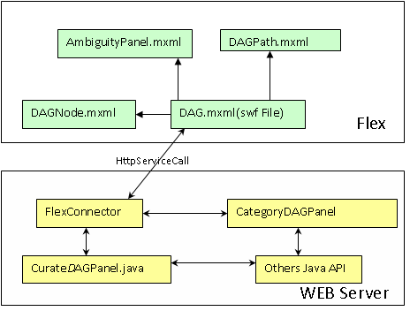

DAGObject: It is a java bean, which is base class for all the components that can be displayed in

AmbiguityPanel.mxml: Flex component to show all the paths and allows admin to choose one which will be part of curated path.

DAGNode.mxml: Flex component to represent a link between two nodes. The java representation of this is DAGNode

DAGPath.mxml: Flex component to represent a link between two nodes. The java representation of this is DAGLink

DAG.mxml: Main flex component which displays all other components. This is the class which will get called from java script. This is flex side of the component

FlexConnector: This class is java side of the UI component. All communication from java to flex will be handled by HTTPSevice calls between DAG.mxml and FlexConnector

CategoryDAGpanel: This extends DAGPanel
CuratedDAGPanel

DAGPanel: It contains all the business logic needed for path curation.

